2B Physics Independent Investigation.
Name: SUGGESTED ANSWER KEY (32 marks)
In this investigation you will determine the relationship between the length of a wire and its resistance. You will not measure the resistance directly but will calculate it from measuring the current through the wire and the potential difference across different lengths of wire.

Purpose:
To vary the length of a wire within a circuit and thus determine the relationship between the length and the resistance of the wire.

Variables: (4 marks)
Independent variable: length of wire
Dependent variable: Resistance (calculated from PD and current measurements)
Control variables: same reading on power pack, same metres, same leads,
same type of wire, same diameter of wire

Hypothesis: any suitable hypothesis (2 marks)
For example: The relationship between the length of the wire and resistance is directly proportional (linear). So if the length is doubled, the resistance is also doubled

Equipment:
- 2 m nichrome wire (may have a plastic coating)
- scissors to cut and strip wire
- 1 m rule
- power pack and leads
- 50 Ω resistor (only purpose is to reduce current so rheostat can be used)
- 2 x multimeters one to read current through the wire and the other to read potential difference.

Procedure:
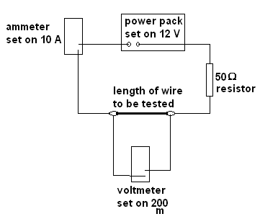
- Set the circuit up as shown to the right.
- Select the lengths of wire you will test, you will need to have at least 5 lengths.
- Cut the wire to the required lengths and strip the ends of plastic if the wire is coated in plastics.
- Place the first length of wire between the two crocodile clips, recheck the lengths.
- Turn the power pack on and record the current and potential difference. Note that 200 m means the reading you record is in mV so change to volts. Turn the power pack off as soon as you have your readings.
- Repeat steps 3 to 5 for a range of length of wire. Enter the readings in the table provided. You do not have to use all the rows in the table.

Results: (6 marks)
  - suitable number of lengths e.g. 5 (1 mark)
  - current same value (1 mark)
  - potential difference correctly recorded (1 mark)
  - resistance calculated correctly (2 marks)
  - use of only 2 significant figures for resistance (1 mark)

Length of wire (m) | Current (A) | Potential Difference (V) | Resistance (Ω)
0 | 0 | 0 | 0
0.1 | 0.23 | 0.043 | 0.19
0.2 | 0.23 | 0.083 | 0.36
0.3 | 0.23 | 0.104 | 0.45
0.4 | 0.23 | 0.142 | 0.62
0.5 | 0.23 | 0.170 | 0.74

Processing results:
- Graph the resistance against the length. (4 marks)
- Draw a line of best fit. (1 mark)
- From your line of best fit, calculate the gradient, including the units. (3 marks)

gradient = 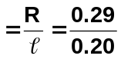
=1.5 Ω m⁻¹

- The resistance of a wire also depends of its resistivity (ρ) and its cross sectional area (A). Resistivity is unique to each type of conducting material so is a constant for that material.
The cross sectional area is the area of the end of the wire, for this wire it is 6.3 x 10⁻⁷ m².
The formula to calculate the resistance is
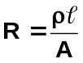
where R = resistance (Ω)
ρ = resistivity (Ω m)
= length (m)
A = cross sectional area (m³)

Given this information, and that in question 3, calculate the resistivity of the metal in the wire.
(2 marks)

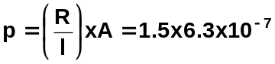
= 9.5x 10⁻⁷ Ω m (actual value 1.0 x 10⁻⁶ Ω m)

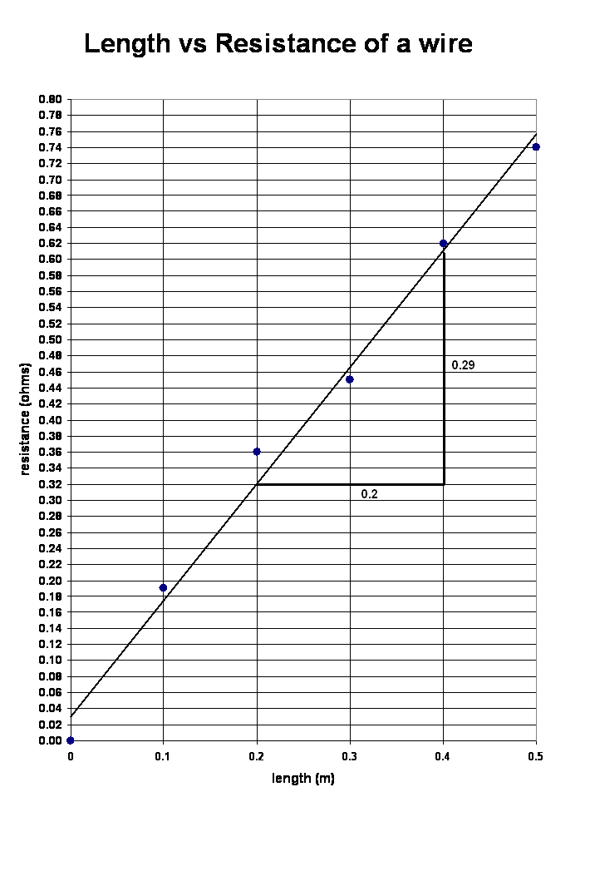

Discussion: (6 marks)
Discuss what your results indicate, for example:
- any physics theories relating to the investigation (1 mark)
- discussion of how the hypothesis relates to the results (2 marks)
- discussion of actual values (2 marks)
- concluding statement about results and investigation (1 mark)
_____________________________________________________________________________________________________________________________________________________________________________________________________________________________________________________________________________________________________________________________________________________________________________________________________________________
_________________________________________________________________________________________________________________________________________________________________________________________________________________________________________________________________________________________________________________________________________________________________________________________________________________________________________________________________________________________________________________________________________________________________________________________________________________________________________________________________________________________________________________________________________________________
__________________________________________________________________________________________________________________________________________________________________
__________________________________________________________________________________________________________________________________________________________________
________________________________________________________________________________________________________________________________________________________________________________________________________________________________________________________________________________________________________________________________________________________________________________________________________________________________________________________________________________________________________________________________________________________________________________________________________________________________________________________________________
__________________________________________________________________________________________________________________________________________________________________
__________________________________________________________________________________________________________________________________________________________________
______________________________________________________________________________________________________________________________________________________________________________________________________________________________________________________________________________________________________________________________________________________________________________________________________________________________________________________________________________________________________
Evaluation: (4 marks)
Discuss any errors that may have occurred and how they could be reduced. (3 marks)
Discuss how the investigation could be improved. (1 mark)
______________________________________________________________________________________________________________________________________________________________________________________________________________________________________________________________________________________________________________________________________________________________________________________________________________________________________________________________________________________________________________________________________________________________________________________________________________________________________________________________________________________________________________________________________________________________________________________________________________________________________________________________________________________________________________________________________________________________________________________________________________________________________________________________________________________________________________________________________________________________________________
_________________________________________________________________________________
_________________________________________________________________________________________________________________________________________________________________________________________________________________________________________________________________________________________________________________________________________________________________________________________________________________________________________________________________________________________________________________________________________________________________________________________________________________________________________________________________________________________________________________________________________________________
_________________________________________________________________________________
_________________________________________________________________________________________________________________________________________________________________________________________________________________________________________________________________________________________________________________________________________________________________________________________________________________________________________________________________________________________________________________________________________________________________________________________________________________________________________________________________________________________________________________________________________________________
_________________________________________________________________________________

